|  |  |  |  |
| --- | --- | --- | --- |
| LAB 6 Web Media  (GIMP Version)  |  | | --- | | What You Will Learn   * Some of the basic commands in GIMP * How to save JPG, GIF, and PNG images * How to use the <video> and <audio> elements |  |  | | --- | | Approximate Time  The exercises in this lab should take approximately 30 minutes to complete. | |  | |
| Fundamentals of Web Development, 2nd Ed  Randy Connolly and Ricardo Hoar |
| Textbook by Pearson  http://www.funwebdev.com  Date Last Revised: Feb 11, 2017 |

## Common Image Tasks

|  |
| --- |
| Preparing Directories |
| 1 | If you haven’t done so already, create a folder in your personal drive for all the labs for this book. |
| 2 | From the main labs folder (either downloaded from the textbook’s web site using the code provided with the textbook or in a common location provided by your instructor), copy the folder titled lab06 to your course folder created in step one. |
| 3 | This lab is going to also make use of a free icon font set called Sosa, which is available from http://tenbytwenty.com/?xxxx_posts=sosa/. You will need to download and install this font in order to complete the logo creation exercise. |

GIMP (Gnu Image Manipulation Program) is a complex open-source image editor. We will only be scratching the surface of this software in order to show you how to accomplish some typical web-related tasks. There is also a version of this lab using the proprietary Adobe Photoshop image editor instead of GIMP.

|  |
| --- |
| Exercise 6. — Image Formats |
| 1 | Start GIMP and open the file british-museum.jpg.  *GIMP uses separate windows for each file you are working on, and a single toolbar that holds all the views for layers, paths, and tools. At the top of each window (for each file) there are menu options for many of the features you'd expect like resizing, color, filters, cropping and more.* |
| 2 | There are several ways to zoom in GIMP. The Zoom Tool lets you zoom by clicking on the image (unzoom by Ctrl clicking). The (+) and (-) keys will also increase and decrease the zoom factor in steps. The easiest is at the bottom of each file window where you can type a new ratio ro choose from some common zoom levels.  However, you'd like zoom to 1600% |
| 3 | Use the Square area selection tool to choose just a part of the image. When finished, choose *Layer | Crop to Selection* to crop the image (see Figure 6.1).  The Crop tool allows you to select an area of an image and discard everything outside this area. Notice as well the checkerboard pattern: this is GIMP’s way of displaying transparent pixels. |
| 4 | Press Ctrl-Z to undo the last step. You can also use the Edit | Undo menu. |
| 5 | Press Ctrl-Y again to redo the crop (or redo anything for that matter) |
| 6 | Use the Eyedropper Tool and click in the image.  This changes the current foreground color to whatever color in the image that you sampled with the Eyedropper. The current foreground color is visible in the Set Foreground Color (see Figure 6.2). |
| 7 | Double-click on the current foreground color swatch (see Figure 6.2).  This will display the Color Picker. Notice that you can use this dialog to convert between different color models. |
|  | Close the image without saving it. |

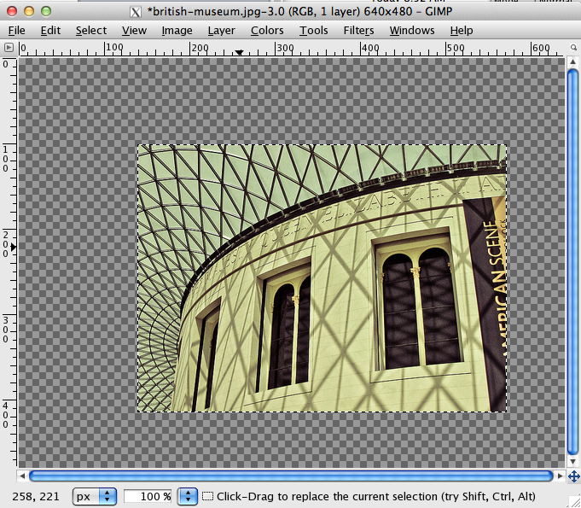

Figure 6.1 – Using the Crop Tool



Figure 6.2 – Setting the Foreground Color

|  |
| --- |
| Exercise 6. — Resizing Images |
| 1 | Open the file british-museum.jpg. |
| 2 | Use the Image | Scale Image menu command.  This dialog allows you to resize an image by specifying a different width and height. |
| 3 | Under Quality, you may choose a type of Interpolation  You can resize the image by adding (or removing) pixels from the image. When Interpolating is turned off, then the nearest neighbor algorithm is used. |
| 4 | Select the *Linear* interpolation method and change the width to 800 pixels then click ok.  Notice that modest increases in the size of a photographic image will not have especially adverse effects on the quality. |
| 5 | Press Ctrl-**Z/Ctrl-Y** repeatedly to undo/redo the resizing. Compare the quality before and after the resizing. |
| 6 | Use the Image | Scale Image menu command and resize the image to 100 pixels wide. Click Ok.  When you are decreasing the size of an image, the loss of quality is generally not as noticeable. |
| 7 | Close the image without saving. |
| 8 | Open the file british-museum-tiny.jpg. |
| 9 | Use the Image | Scale Image menu command and resize the image by setting its width to 640 pixels. Click Ok.  Notice that the quality is now very poor. Thus making a large increase in the size of an image will result in a very poor image. |
| 10 | Use the File | Revert menu command.  This shortcut is the equivalent of closing a file without saving and then reopening. |
| 11 | Use the Image | Canvas Size menu command.  This command lets you increase or decrease an image's canvas size. |
| 12 | In the Canvas Size dialog, change the width to 400 pixels, and set the offsets as shown in Figure 6.3 (this will add the pixels on the right side of the image) and then click Resize. |
| 13 | Close the image without saving. |

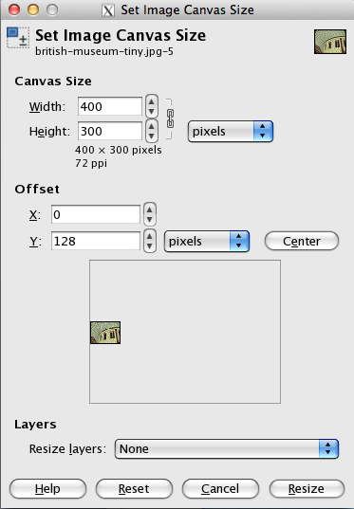

Figure 6.3 – Canvas Size dialog

|  |
| --- |
| Exercise 6. — Working with Vector Information |
| 1 | Open the file building-raster.jpg. |
| 2 | Zoom into 1600%. (See Exercise 1 for direction on zooming) |
| 3 | Close the file and then open building-vector.eps.  This is a vector-based file format, and GIMP will rasterize this image when it opens it. |
| 4 | In the Rasterize EPS Format dialog, specify a width of 300 pixels and then click Ok.  Rasterizing is the process of turning vector information into pixels. The larger the dpi, the larger the resulting rasterized version of the eps. |
| 5 | Use the Zoom Tool and zoom in the image.  Notice that it now consists of pixels. |
| 6 | Close the file then use the File | New menu command. In the New Dialog, set the width and height to 500 pixels then click Ok. |
| 7 | Use the File | Open as Layer menu command and select the file building-vector.eps. accept the default settings and Click Ok.  This places the vector file as a raster object. This object can then be resized (or transformed in other ways) but it loses all vector information. In GIMP you should import vector images as large as is feasible (600dpi) and scale down since scaling up raster images reduces their quality more than scaling down. In contrast, Adobe's Photoshop resamples the vector image every time it is resized, making this process unnecessary. |
| 8 | The new layer is now displayed within the window. It can be transformed using the GIMP resize tool or in the menu (*Layer->Scale* ). With the resize tool selected try dragging on the handles to resize the layer. Holding down the CTRL key while dragging on a corner handle will maintain the aspect ratio. You can rotate the object by selecting the rotate tool. When finished, you will need to confirm the visible transformation in the transform dialog and hit "scale". |
| 9 | Use the Zoom Tool and zoom in the image.  Notice that it now consists of pixels. If you want it to be less pixelated, you must go back to step 3 and input a higher dpi. |
| 10 | Examine the Layers windows (see Figure 6.4). Each layer in GIMP can contain different information and can be manipulated independently of the other layers. You can click on the eye icon next to the layer name to toggle its visibility. |
| 11 | Use the Type Tool to add some text to the image. When you click in the image with the Text Tool, a box will open to accept text. The tool details will show controls for the font face, size, color and more.  Notice as well that a new layer has been created. You can now manipulate the text independently. |
| 12 | Select the Move Tool. This tool allows you to move pixels on the current layer. |
| 13 | Drag on the text you just entered to move it to a different part of the image. |
| 14 | Click on the building-vector layer in the Layers Window to make it the current layer. Then with the Move Tool still selected, drag the building to move it. |
| 15 | Use the File | Save As menu command. Save the file in GIMP's own file format and name it lab06-exercise03.xcf. After saving it, close the file. |

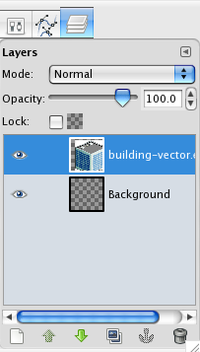

Figure 6.4 – Layers window

## Saving Web Images

|  |
| --- |
| Exercise 6. — Saving a JPEG |
| 1 | Open verona.tif.  A TIF file is a lossless raster file format. TIF files are often used as a way to move graphical information from one application to another with no loss of information. |
| 2 | Use the File | Save As menu command.  This will display the Save dialog. This dialog can be used to export to any type of file you'd like. Since we are saving for web you should save to PNG, JPG or GIF. |
| 3 | Within the Save As dialog type lab06-exercise04.jpg and hit enter.  This will bring up a dialog to set all the options of your JPG image and allow you to experiment. Alternatively, consider adding the "save for Web", free plugin for gimp, which will let you see the original and preview side-by-side. |
| 4 | In the dialog check the "show preview" option (see Figure 6.5). The view of your image will now show a preview of the file to be saved. Experiment with the different quality settings. Under the quality settings slider you can see the resulting file size. There are also advanced options you can access.  In Figure 6.5, we have lowered the quality to 7% to illustrate some of the obvious effects of compression. |
| 5 | Click the Save button. You file will be saved as lab06-exercise04.jpg. |

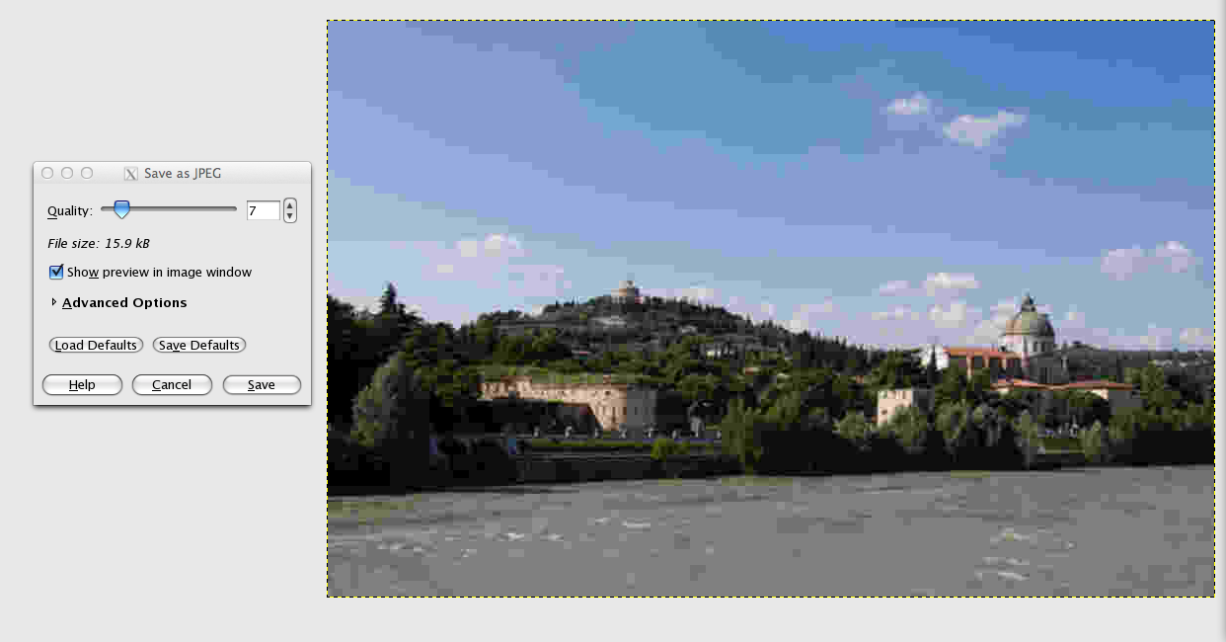

Figure 6.5 – Saving a JPG

|  |
| --- |
| Exercise 6. — Saving a GIF |
| 1 | Open CRM-logo.psd and examine its layers. |
| 2 | Turn off the visibility of the background layer. |
| 3 | Use the **File | Save As** menu command and save the file as lab06-exercise05.gif |
| 4 | You will be asked if you want to make an animation from the layers, or flatten the image. Choose flatten image. |
| 5 | By default GIMP saves 256 color GIF palettes without offering a preview. |
| 6 | The Save for Web plugin adds functionality so you can experiment with the Colors. If you have the plugin you can choose **File | Save For Web** and preview your options  This changes the number of bits per pixel. Under the image the projected file size is shown. |
| 7 | When happy with the result, click the Save button. |

|  |
| --- |
| Exercise 6. — Saving a PNG |
| 1 | Open building-transparency.xcf and examine. |
| 2 | Use the File | Save menu command. Choose GIF from the type drop down or type a file with .gif as the extension like lab06-exercise06.gif. |
| 3 | Use the File | Save for Web menu command again. |
| 4 | This time, choose PNG as the file type. Save the file as lab06-exercise06.png. |
| 5 | When asked you may have to flatten the image, this merges all layers together before saving. You will also be prompted for some advanced image options. The defaults will suffice. |
| 6 | View lab06-exercise06-tester.html in the browser. Notice the halo effects on the GIF due to the fact the GIF transparency is only 1-bit. |

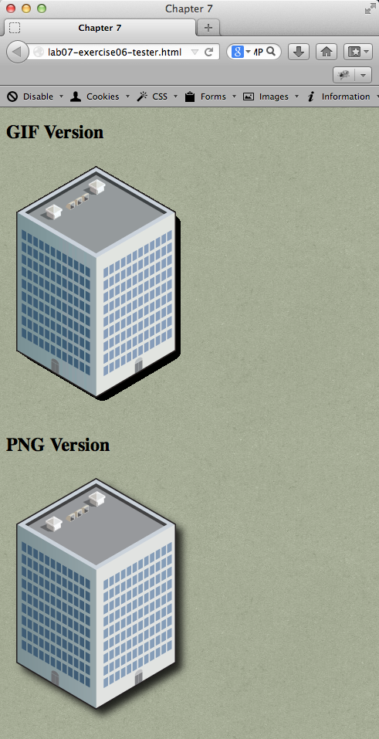

Figure 6.6 – Exercise 6.6 complete

|  |
| --- |
| Exercise 6. — Creating a Logo |
| 1 | Create a new image in Photoshop using the File | New menu. |
| 2 | In the New dialog, set the width to 400 pixels and the height to 150 pixels. Click Ok. |
| 3 | Change the foreground color to ffffcc. Use the **Edit | Fill with FG color** menu command.  This should change the color of the entire background layer. |
| 4 | Select the Type Tool and click in the image. Type 1 into the text window. |
| 5 | Select the Tools Options Dialog and change the font to Sosa (see note at beginning of lab about installing this font), the font size to 72, and the color to b0b5fd.  If you are using the correct Sosa font, the number 1 will show up as a camera icon. |
| 6 | Select the Type Tool and click in an empty part of the image. Type in the text Share. Click the done button. Select the Tools Options Dialog and change the font to Times New Roman Bold, the font size to 60, and the color to 4f59df. |
| 7 | Select the Type Tool and click in an empty part of the image. Type in the text ur Photos. Click the done button. Select the Tools Options Dialog and change the font to Times New Roman, the font size to 48, and the color to 4f59df. |
|  | Select the Type Tool and click in an empty part of the image. Type in the text Y and click the done button Select the Tools Options Dialog and change the font to Times New Roman, the font size to 48, and the color to 4f59df. |
| 9 | Use the Move Tool, and the File | Transform menu command to position and rotate the elements as shown in Figure 6.7. |
| 10 | Save the file as lab06-exercise07.xcf. |
| 11 | Use the File | Save As command and save the file as a PNG. |



Figure 6. – Exercise 6.7 complete

## Working with Audio and Video

|  |
| --- |
| Exercise 6. — Video and Audio Elements |
| 1 | Open and examine lab06-exercise08-audio.html. |
| 2 | Add the following code and test.  <h2>mp3</h2>  <audio src="Sochi-Edit.mp3" controls >  Browser doesn't support the audio control  </audio> |
| 3 | Add the following code and test (ideally in IE and Chrome or Firefox).  <h2>ogg</h2>  <audio controls >  <source src="Sochi-Edit.ogg" >  <p>Browser doesn't support the audio control</p>  </audio>  At the time of writing, IE 10 does not support the Ogg audio format. Notice also that this step illustrates an alternative way of specifying the source. |
| 4 | Add the following code and test (ideally in IE and Chrome or Firefox).  <h2>m4a</h2>  <audio controls >  <source src="Sochi-Edit.m4a" >  <p>Browser doesn't support the audio control</p>  </audio>  <h2>wav</h2>  <audio controls >  <source src="Sochi-Edit.wav" >  <p>Browser doesn't support the audio control</p>  </audio>  <h2>webm</h2>  <audio controls >  <source src="Sochi-Edit.webm" >  <p>Browser doesn't support the audio control</p>  </audio> |
| 5 | Add the following code and test.  <h2>All in one</h2>  <audio controls >  <source src="Sochi-Edit.mp3" type="audio/mpeg">  <source src="Sochi-Edit.ogg" type="audio/ogg">  <source src="Sochi-Edit.m4a" type="audio/mp4">  <source src="Sochi-Edit.wav" type="audio/wav">  <source src="Sochi-Edit.webm" type="audio/webm">  <p>Browser doesn't support the audio control</p>  </audio>  The browser will use the first source format that it supports. Notice also that MIME types are also defined. |
| 6 | Open and examine lab06-exercise08-video.html. |
| 7 | Add the following code and test (ideally in IE and Chrome and Firefox).  <h2>mp4</h2>  <video id="video" poster="video-preview.jpg" controls width="480"  height="360">  <source src="rocky.mp4"  type='video/mp4; codecs="avc1.42E01E, mp4a.40.2"'>  not supported  </video>  <h2>ogg</h2>  <video id="video" poster="video-preview.jpg" controls width="480"  height="360">  <source src="rocky.ogv" type='video/ogg; codecs="theora, vorbis"'>  not supported  </video>  <h2>WebM</h2>  <video id="video" poster="video-preview.jpg" controls width="480"  height="360">  <source src="rocky.webm" type='video/webm; codecs="vp8, vorbis"'>  not supported  </video> |
| 8 | Add the following code and test.  <h2>flash </h2>  <object type="application/x-shockwave-flash" data="rocky.swf" width="480"  height="360">  <param name="allowfullscreen" value="true">  <param name="allowscriptaccess" value="always">  <param name="flashvars" value="rocky.mp4">  </object> |